Project Report: Telecom Customer Churn Analysis
Author: Prateek Bag
Date: March 10, 2026
1. Project Overview
The primary objective of this project is to identify key drivers of customer attrition within the telecom sector and develop a predictive model to proactively identify at-risk customers. By analyzing historical customer data, we aim to reduce churn rates and optimize retention strategies across various demographics and service types.
2. Executive Summary
- Total Customer Base: 6,418 customers analyzed.
- Current Churn Rate: 26.99% (Total Churn: 1,732 customers).
- Primary Churn Driver: Competition, accounting for 761 churned customers (approx. 44%), with "Competitor had better devices" being a recurring reason.
- High-Risk Segments: Customers on "Month-to-Month" contracts show a significantly higher churn rate of 47%.
- Geographic Insights: Jammu & Kashmir (57%) and Assam (38%) exhibit the highest regional churn rates.
3. SQL Data Engineering
Extensive SQL processing was conducted to clean the data and prepare views for both analysis and machine learning.
- Data Cleaning: Handled null values by replacing missing entries with "None" for categorical fields (e.g., Value_Deal, Internet_Type) and "No" for service-related flags.
- Feature Engineering: Created dedicated views for model training (vw_churn for stayed/churned status) and future predictions (vw_joined for new joiners).
- Metric Calculation: Developed queries to calculate churn percentages by gender, state, and contract type to validate dashboard accuracy.

4. Churn Analysis Dashboard
The dashboard is split into two strategic views: Executive Insights and Customer Demographics.
Page 1: Executive Insights & Service Performance
- Contract Influence: Month-to-Month contracts are the most volatile, while "Two Year" contracts have a negligible churn rate (approx. 2%).
- Service Impact: Customers with "Fiber Optic" internet show a high churn rate of 58% compared to "Cable" (36%) or "DSL" (32%).
- Payment Behavior: Customers using "Mailed Check" (38%) and "Bank Withdrawal" (34%) are more likely to churn than those on Credit Cards.
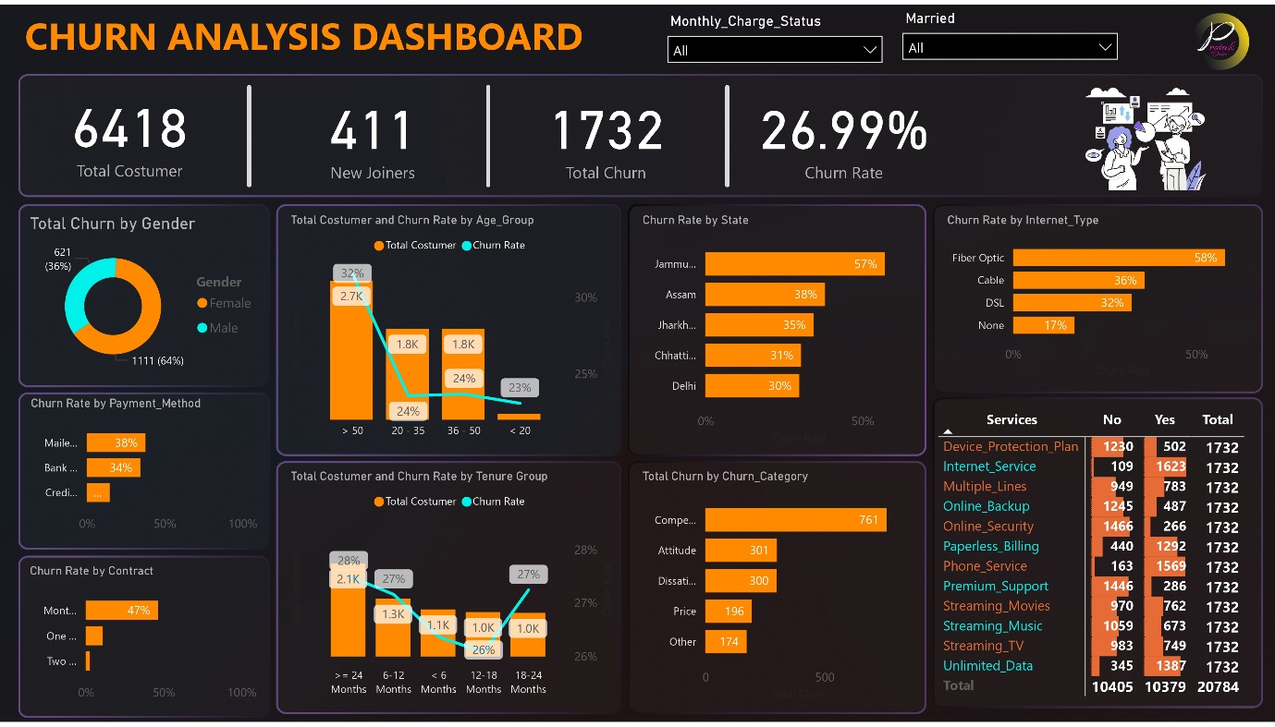

Page 2: Demographic & Behavioral Analysis
- Age Profile: The "36-50" age group contributes the highest volume of churn (621 customers), followed closely by the "> 50" group.
- Tenure Correlation: The highest churn occurs within the first 6 months of tenure, emphasizing the need for better onboarding.
- Social Status: Non-married customers exhibit higher churn propensity than married customers.
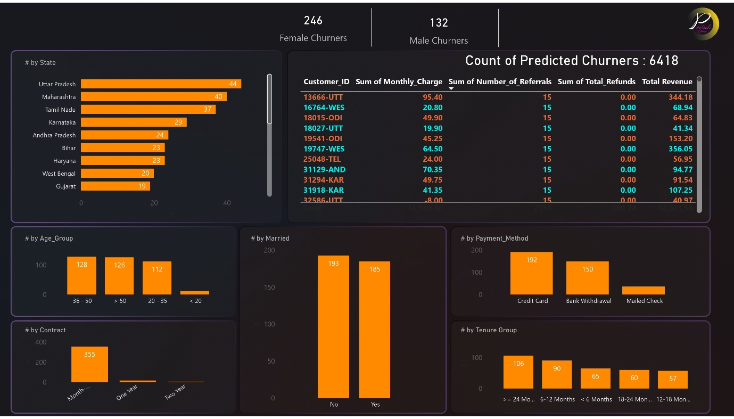
5. Predictive Analytics & Machine Learning
A Random Forest Classifier was implemented to predict future churn.
- Model Performance: The model achieved an overall accuracy of 84%, with a precision of 0.78 for the churned class.
- Key Features: Contract, Tenure_in_Months, and Monthly_Charges were identified as the most significant predictors in the Python implementation.
- Future Risk: Applied the model to 411 new joiners to proactively flag those with high churn probability (labeled as "1" in the prediction file).
6. Strategic Recommendations
- Retention for Fiber Optic Users: Investigate the high (58%) churn rate in Fiber Optic services to ensure network stability or competitive pricing.
- Contract Migration: Incentivize "Month-to-Month" customers to move to "One Year" or "Two Year" contracts through discounts.
- Regional Focus: Launch targeted loyalty programs in Jammu & Kashmir and Assam to combat high regional attrition.

